CIS 8040: Assignment 3

Hao Nguyen, Quan Le, Anirudh Chaudhary

APPLICATION:

We design a bank support system database that helps customers with their transaction and statements. There will be one advisor who can assist with their issues at any office location. It is important to keep track of the advisor who works on the customer with which type of account because banking system requires an accurate procedure in every statement or each transaction.

USER REQUIREMENT SPECIFICATIONS:

1. All banking users requires to have an ID, first and last name, phone number and date of birth.
2. Each customer can open at least 1 account with the bank to be an active member. Each account has an ID associating with the customer, a type (i.e. Checking, saving, etc.) and a balance in it.
3. Whenever the customer uses the account to make a payment, the transaction will show the amount being use, the current balance, and the date that the transaction posted. The transaction can also have a description (i.e. Pay bills). The transaction is unique by the transaction id so that advisor can easily look it up.
4. The combination of all transactions within that month will show in the statement with a specific range and belong to a specific account number. The statement of each month has an id for classification.
5. Whenever the customer has a problem with their account, they have an option to request an appointment with the advisor to assist them. Each appointment requires to have an id, date and time, employee id who works on the case, the office’s location, and customer who is involved. They have an option to leave a note on the issue.
6. An office will be an indication on where the appointment located. It will have office id and the address.
7. The advisor who accommodates the customers for their appointment will have an employee id number, name, email, and phone number.

ENTITY-RELATIONSHIP DIAGRAM



RELATIONAL MODEL



**CREATION.SQL**

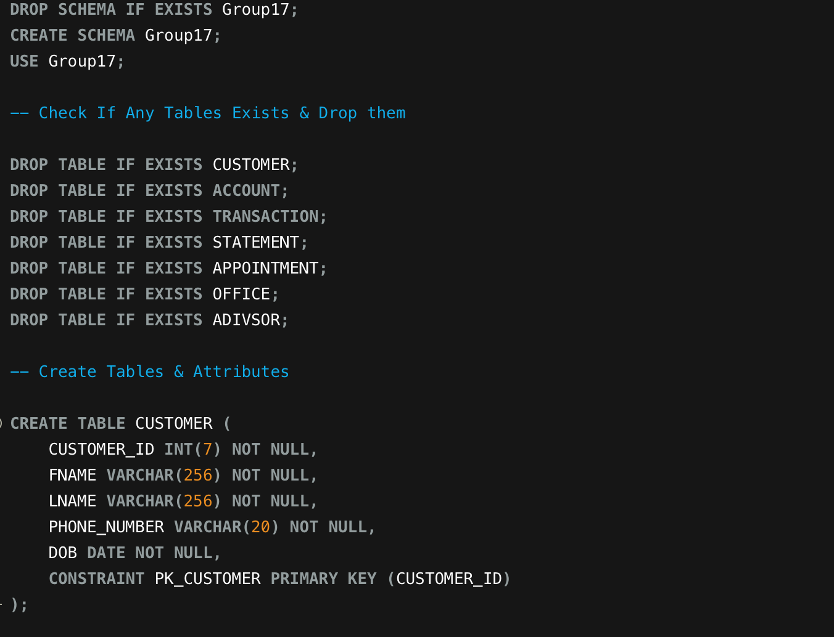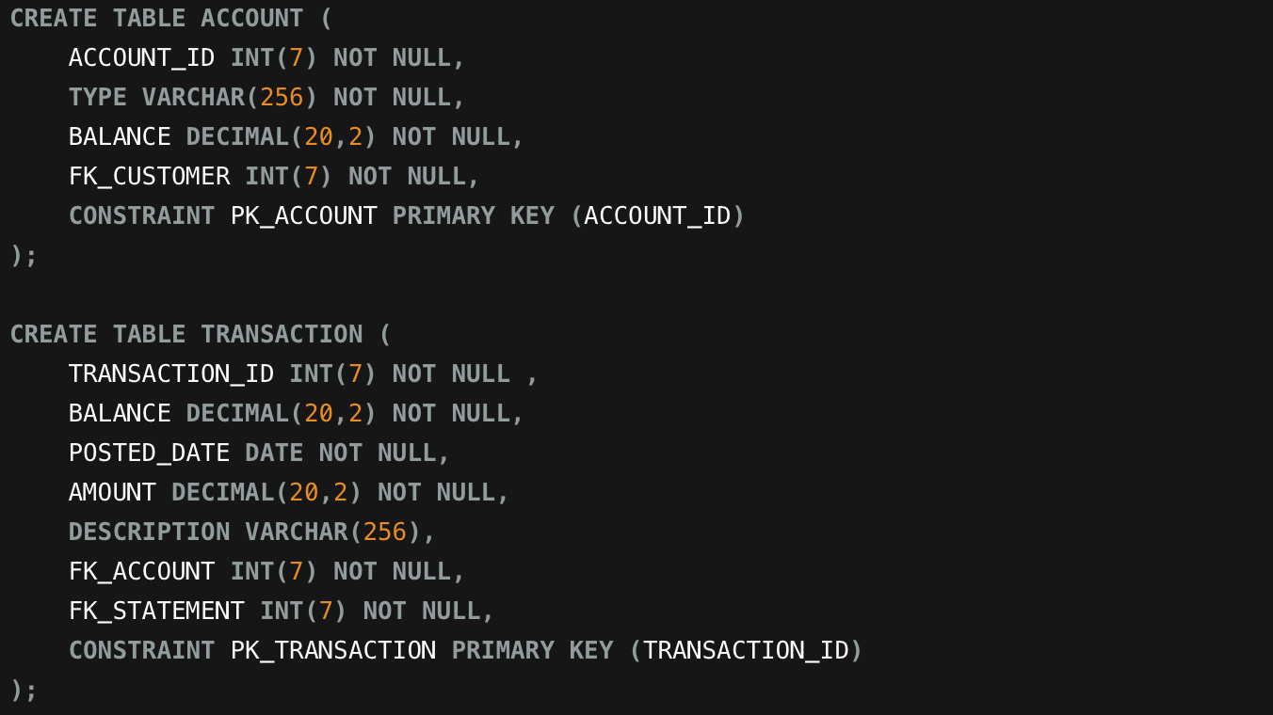

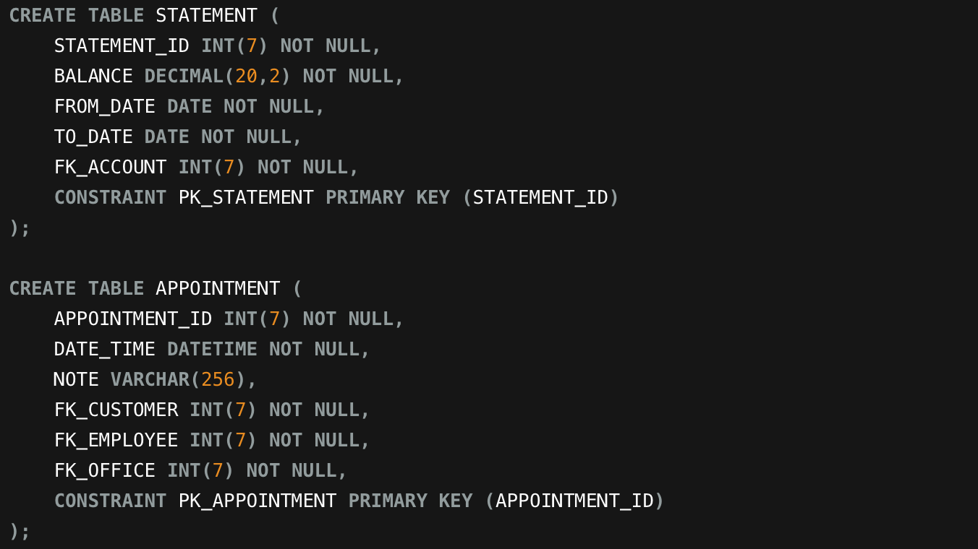

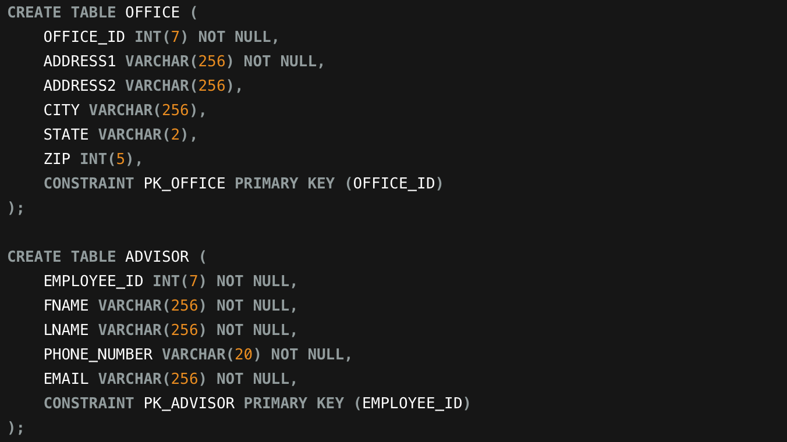

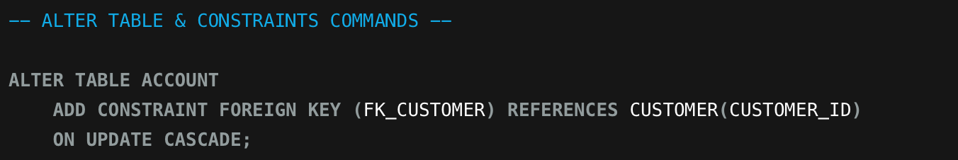

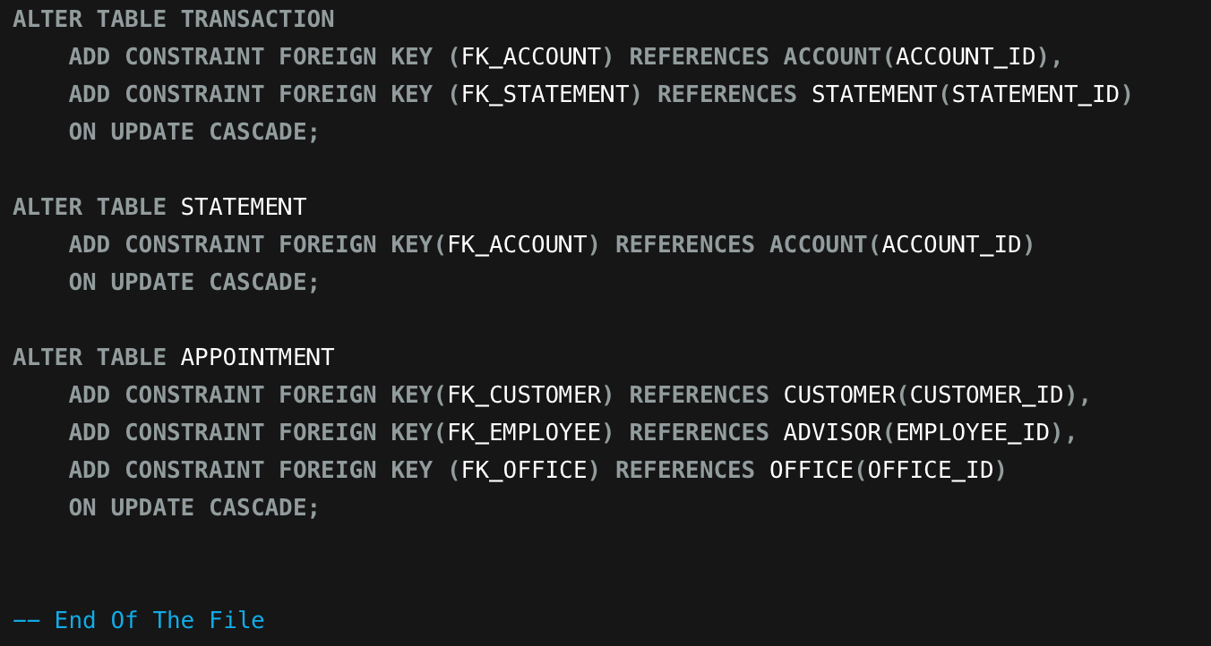

**INSERTION.SQL**

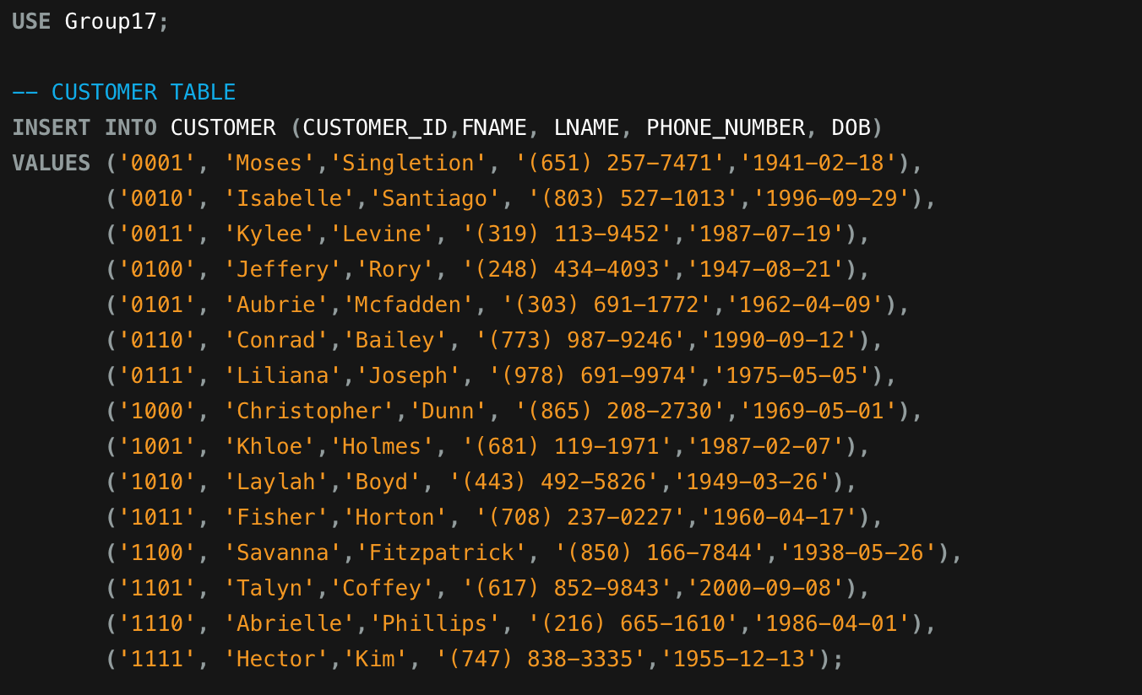

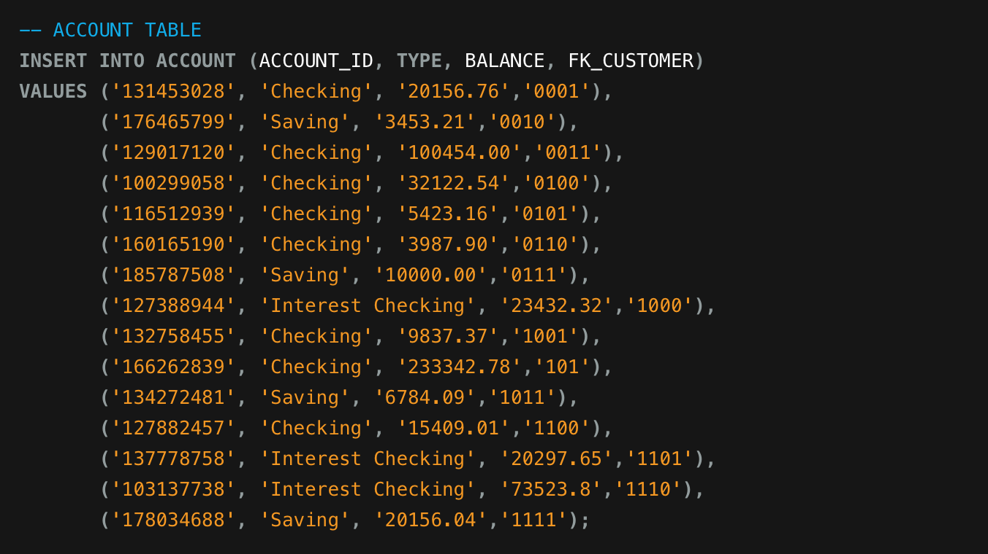

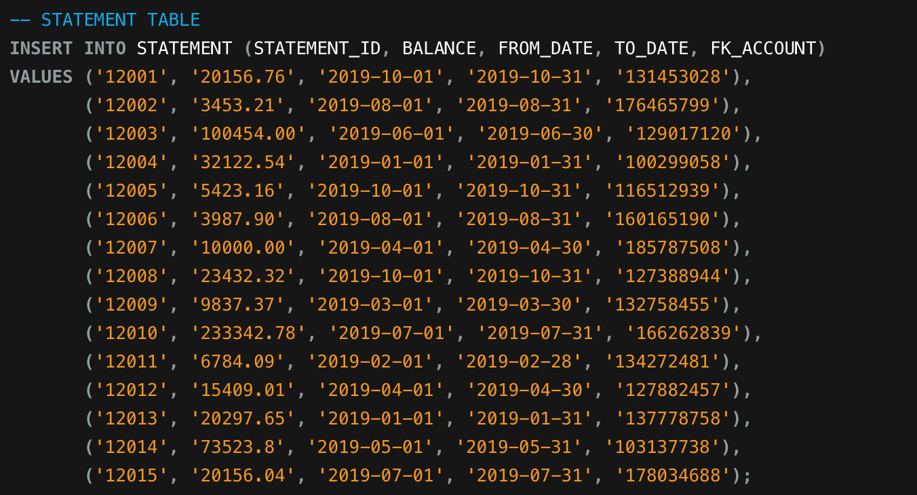

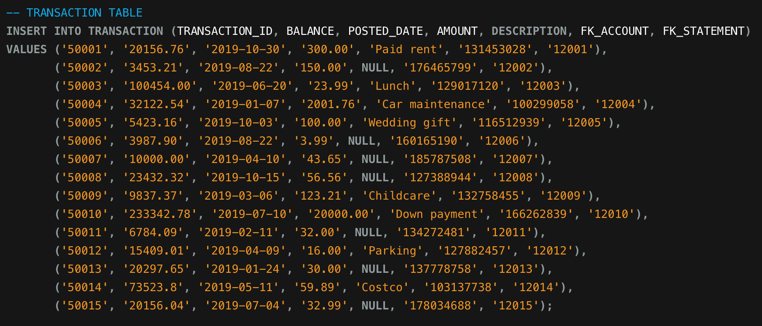

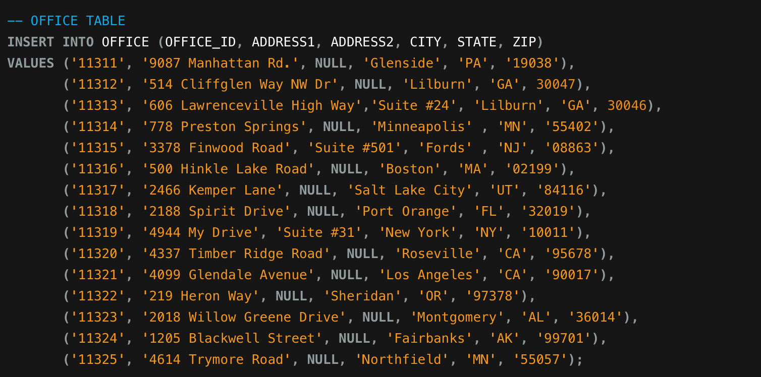

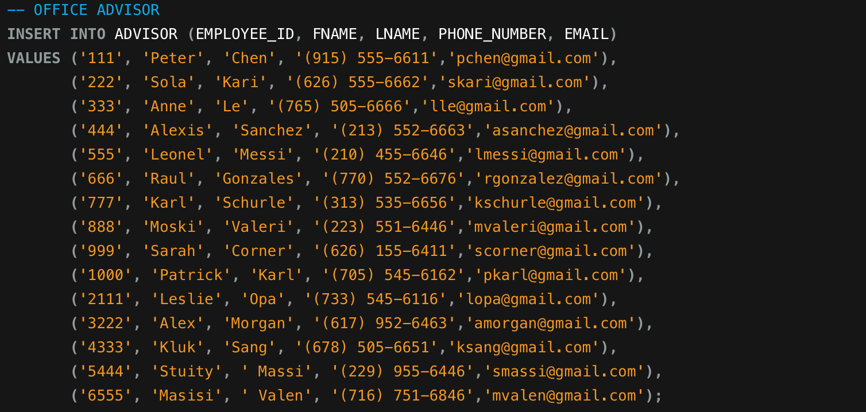

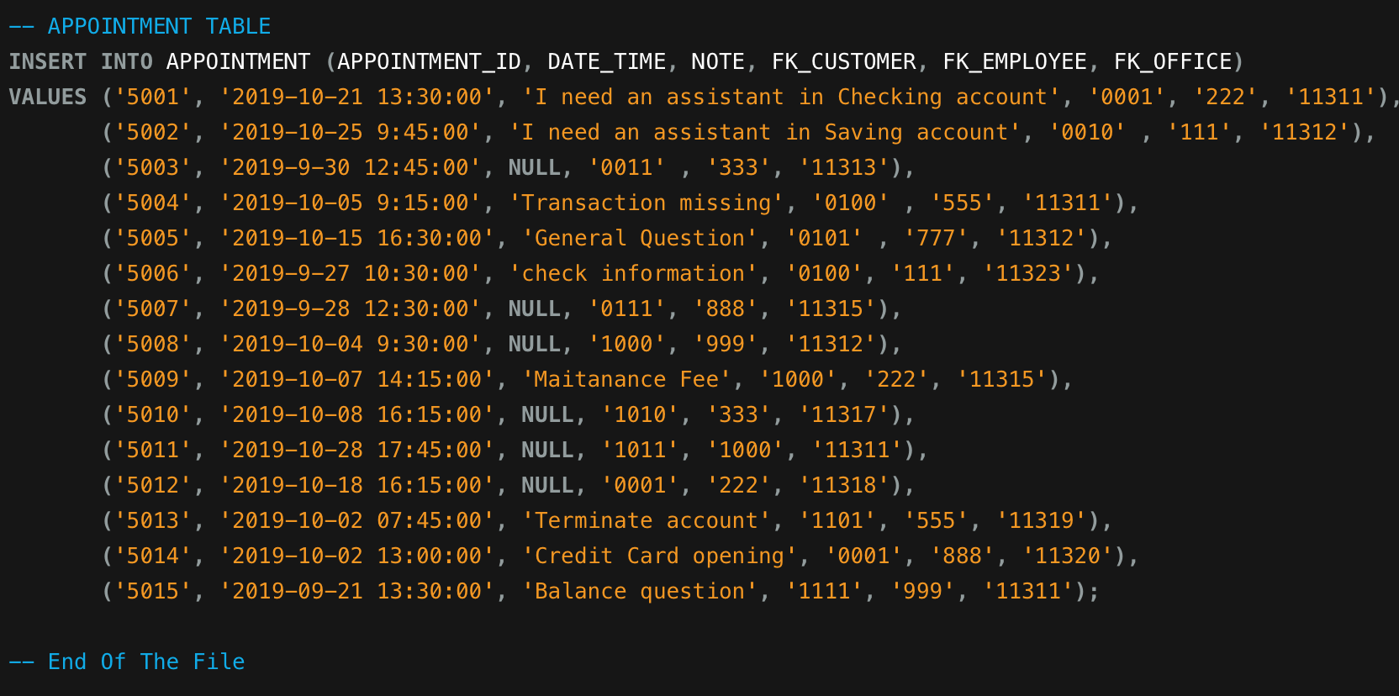

QUERIES:

**-- 01. Retrieve all the customer’s name who has appointment on September.**

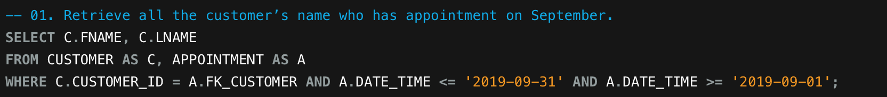

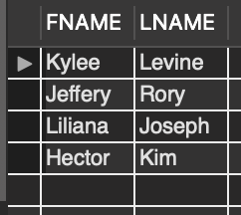

**-- 02. Get customer’s last name and account type with the highest balance on the account.**

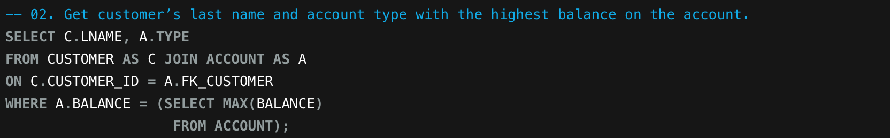

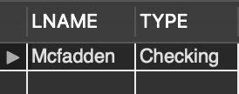

**-- 03. Find all the advisor who does not assign to any appointment.**

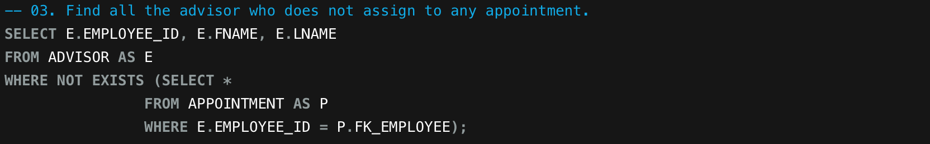

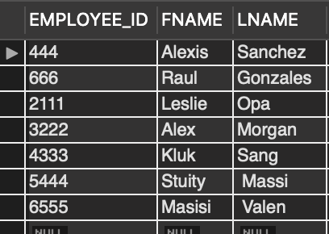

**-- 04. Get the office’s address with more than 1 appointment.**

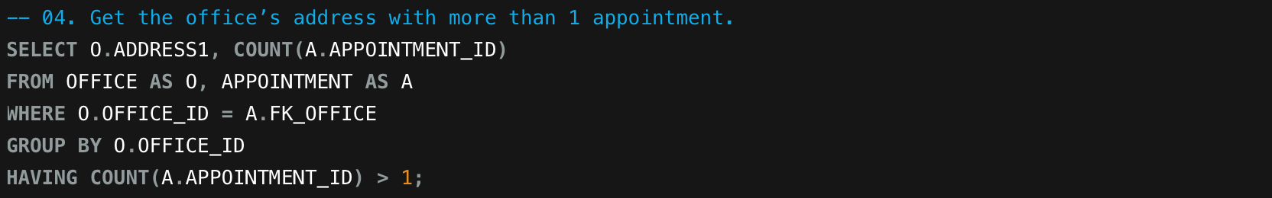

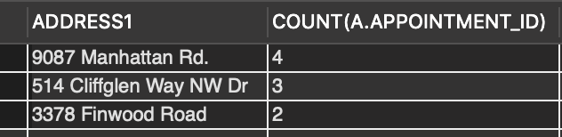

**-- 05. Get the advisor’s first and last name with number of appointments.**



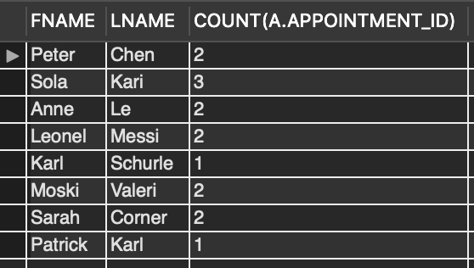

**-- 06. List customer’s first and last name with the interest checking account.**



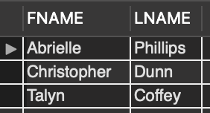

**-- 07. Return all the customers who has birthday on 1940-1950.**

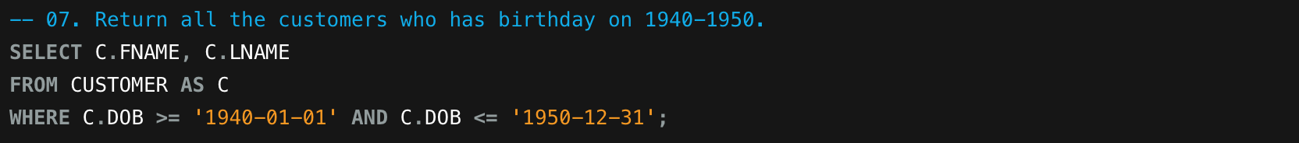

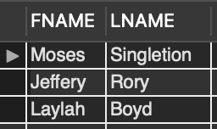

**-- 08. Show Top 10 customers with most appointments.**

Select Top 10 X.CountN , cus.LName, cus.FName

From Customer as cust join

(Select Count(AppointmentID) as CountN, c.CustomerID

From Customer as c join Appointment as a

Group By c.CustomerID ) as X on cust.CustomerID = c.CustomerID

Order by X.CountN desc

**-- 09. Return first name and last name of statement = ‘12006’.**

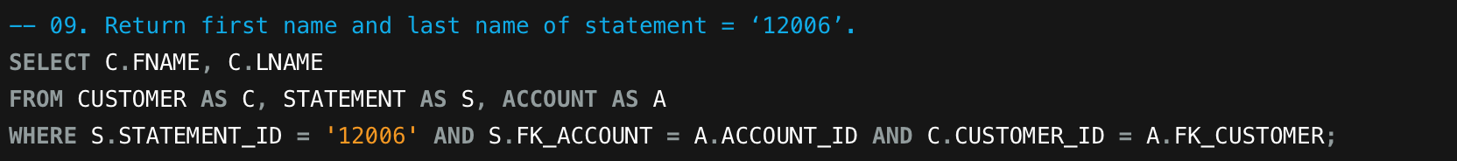

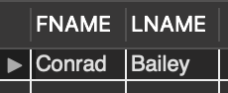

**-- 10. Get balance between 100,000 to 300,000.**

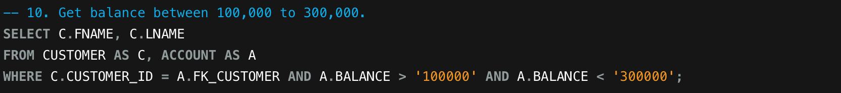

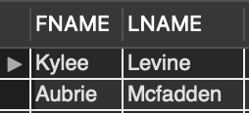

DATA QUALITY PROBLEMS:

1. Incorrect Data Entry:

This kind of data quality problem can arise due to a human error while entering the data into the database system. There can be huge impact on the database as it can lead to wrong decision-making and failure to backtrack the information.

In this example, the bank manager wants to know that which all transactions above $1,00,000 were carried out in which financial year as the tax department wants this information. After running the query, he got the following results:

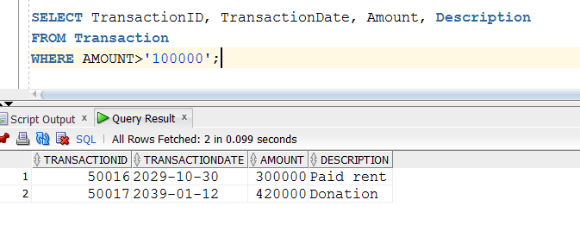

Since, the transaction date is greater than the current date for both the transactions, which is not possible, the relevant and correct information cannot be retrieved from the database.

1. Duplicate Entry:

This kind of data quality problem arises when primary key constraints are not defined properly while designing the database. It will allow a user to enter duplicate entries in that relation after which there is no way to distinguish the data entries uniquely.

In this example, the user wants to know a specific appointment has been scheduled at which location. The following query can be run to get relevant results:

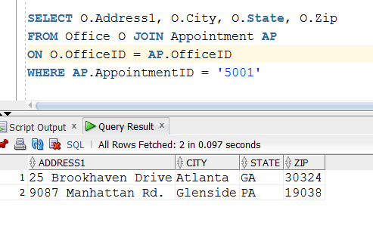

As we know, an appointment cannot be held at two locations, it is clear example of data quality problem due to which a bank representative won’t be able to tell the customer where his/her appointment has been allocated.

1. Inconsistent Formats:

This type of data quality problem arises in the real world when the data types and formats for storing the basic information in the database is not pre-decided. This will lead to a lot of error prone results which will impact the information flow and decision-making done by the management.

For example, if the format for entering a phone number is not pre-determined then it can be entered quite differently. If such becomes the case, then if the user wants to get the details of the customer with phone number starting with ‘661’ then he might not be able to retrieve the correct data.

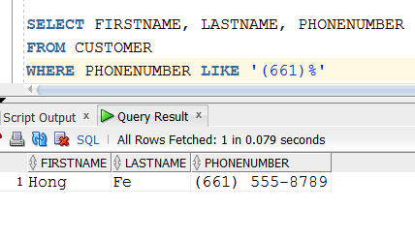

In the database, there exists two customers who have phone numbers starting with ‘661’ but due to inconsistent formatting, the user is unable to get the correct results.

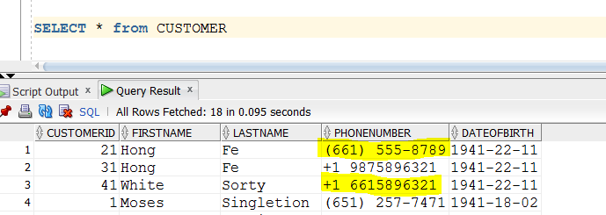

PRIVACY & SECURITY ISSUES: